mx.rarserver V1.0 @ created by Bsk / April-26

> Overview
mx.rarserver is a multi-server IRC tool designed to simplify the distribution of folders across different IRC networks. The system can operate simultaneously on multiple servers, listening for requests in configured channels. When a user requests a folder, the script locates it, compresses it into a .rar file, and sends it directly to the user through DCC.
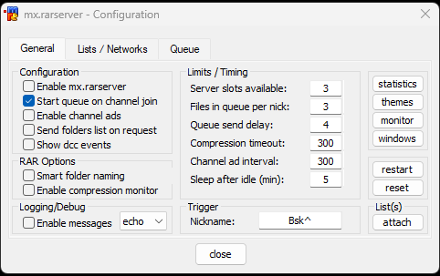
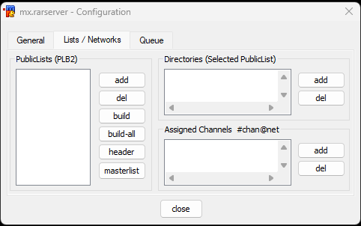
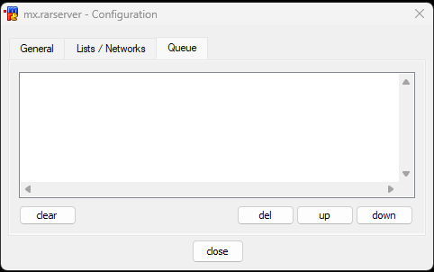

> Performance
To improve performance when working with large collections, the system uses a dedicated DLL for exact folder searching and an external list builder to generate public lists more efficiently than native script methods. Compression is handled by an external worker, reducing load inside mIRC and improving stability.
> How it works
The system listens for requests using configurable triggers in specific channels or private messages. When a valid request is detected, the requested folder is added to a controlled queue. The system processes one job at a time, creates the .rar file, and sends it automatically through DCC.
> Compression Engine
Compression is handled by mxrar.exe, a silent external worker. During the process, it creates control files such as .running, .ini, and .log, allowing the script to monitor progress, detect results, and handle errors reliably.
> Monitoring
mx.rarserver includes optional compression monitoring, timeout control, and watchdog recovery. It can detect stalled jobs, failed compression, missing files, network interruption, and locked output files.
> After Compression
Once the .rar file has been created, it is sent through DCC. After the transfer finishes or fails, the generated .rar file is removed automatically from the work directory.
> Statistics
The system includes a statistics window showing requests, completed compressions, sent folders, failures, and transferred data. It also tracks DCC activity, transfer speed, queue status, and channel advertisements.
> Important
mx.rarserver is an independent script designed to work alongside existing IRC distribution systems. To avoid conflicts with OmenServe, it must use its own dedicated trigger. Using the same trigger or nick as OmenServe may generate command conflicts.
> Compatibility
This script does not implement CTCP request handling. It is meant to operate as a complementary module for existing IRC servers such as OmenServe, which already provide CTCP and XDCC server functionality.
> Attach function
mx.rarserver includes an optional Attach function that allows the generated public list in .txt format to be integrated into the list of another active IRC file server. This allows mx.rarserver to operate as a complementary RAR distribution system without requiring advertisements or separate public list triggers. The function is useful when another server already handles XDCC, CTCP, or the main public list distribution, allowing both systems to work together using a single centralized list.

> Folder Name Protection
mx.rarserver includes an optional smart folder naming feature. This helps prevent conflicts when different albums contain subfolders with identical names, such as CD1 or CD2 and several folder names, by creating safer generated archive names.

Example:
Requested
!Bsk^ F:\ Los Tigres Del Norte - Los Dos Plebes\CD1.rar

Generated archive
!Bsk^ F:\ Los Tigres Del Norte - Los Dos Plebes\ Los Tigres Del Norte - Los Dos Plebes - CD1.rar

> How to install
- Copy the mxrarserver folder into your mIRC directory
- Example: C:\mIRC\mxrarserver
- Open mIRC
- In the Status window, type:
/load -rs mxrarserver\mxrarserver.mrc

> How to install

1. Download: https://github.com/mxbiteck/mx.rarserver/releases/tag/v1.0
2. Copy the mxrarserver folder into your mIRC directory
3. Open mIRC
4. In the Status window, type:

/load -rs mxrarserver\mxrarserver.mrc

> Operation Guide

Enable mx.rarserver: Enables or disables the entire system and its operations.
Start queue on channel join: Automatically starts the queue when joining configured channels.
Enable channel ads: Enables automatic advertisement messages in active channels.
Send folders list on request: Allows users to request and receive folder lists.
Show dcc events: Displays DCC transfer events in the monitoring system.
Smart folder naming: Applies adaptive naming logic to avoid conflicts during processing.
Enable compression monitor: Enables the dialog that tracks compression progress.
Enable messages: Enables system output messages and notifications.
Server slots available: Defines the maximum number of simultaneous DCC sends.
Files in queue per nick: Limits how many active requests each user can have.
Queue send delay: Controls the delay between each queue processing cycle.
Compression timeout: Defines the maximum time allowed for compression tasks.
Channel ad interval: Sets how often advertisement messages are sent to channels.
Sleep after idle (min): Defines inactivity time before entering low-activity mode.
Nickname: Defines the system identifier or trigger used for requests.

Statistics: Opens the statistics dialog to view usage metrics and system activity.
Themes: Opens the themes dialog to customize the visual appearance of the script.
Monitor: Opens the monitor dialog to observe real-time system and DCC activity.
Windows: Opens the windows management dialog to control layout and visibility.
Restart: Restarts the system, reinitializing timers and runtime variables.
Reset: Resets system state and configuration based on internal logic.
Attach: Opens the dialog used to attach or manage public lists.

Publiclists: Displays all configured public lists available, double click to see the list.
Add list: Creates and adds a new public list configuration.
Remove list: Deletes the selected public list from the system.
Build list: Generates the selected list using the external builder.
Build all: Generates all configured lists in a single operation.
Header: Opens the dialog to configure the list header file.
Masterlist: Opens the dialog to manage the global master list.
Directories: Displays all directories assigned to the selected public list.
Add directory: Adds new directories to the selected list configuration.
Remove directory: Removes directories from the selected list.
Assigned channels: Displays channels linked to the selected list.
Add channel: Assigns a new channel to the selected public list.
Remove channel: Removes a channel from the selected list.
Queue list: Displays all current pending requests in the queue.
Remove item: Removes the selected request from the queue.
Clear queue: Removes all pending requests from the queue.
Move up: Moves the selected request higher in priority.
Move down: Moves the selected request lower in priority.
> Notes
If you have questions, suggestions, or encounter any issues while using this system, feel free to contact the author.

Regards
Bsk
Statistics
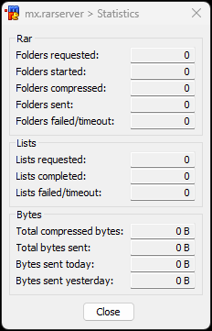
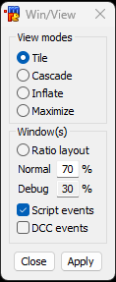
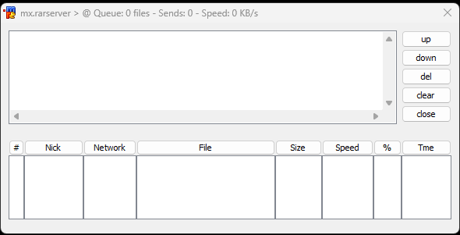
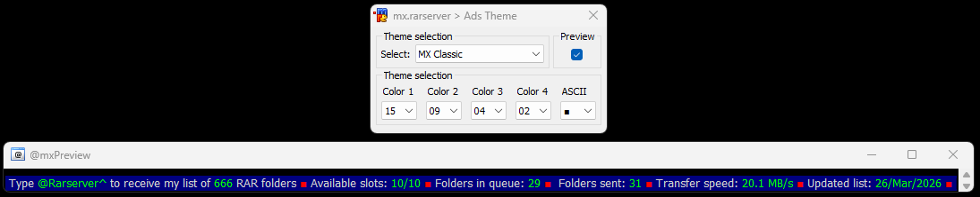
Windows
DCC Send Monitoring
Ad Theme

